14. How to create a timeline report to view food and fluid intake

- Click on the Administration ‘cog’ in the vertical menu on the left-hand side.

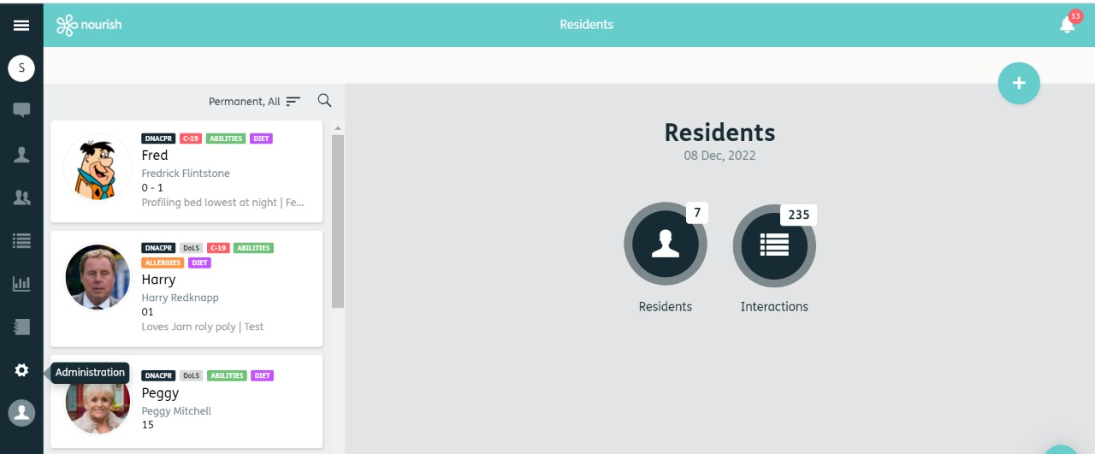
1.

- This will open the Administration Menu, click on ‘Reports’.
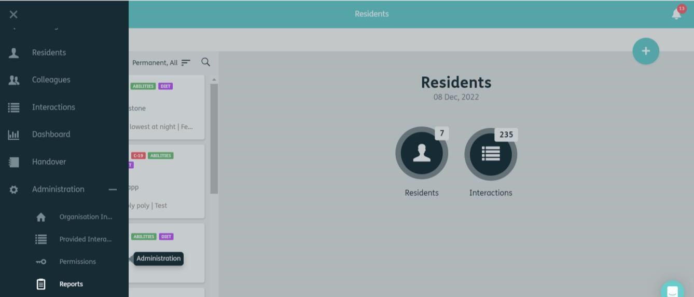

2.

3. This will open the reports menu. To create a new report, click on the ‘Blue Plus’ in the top right corner.

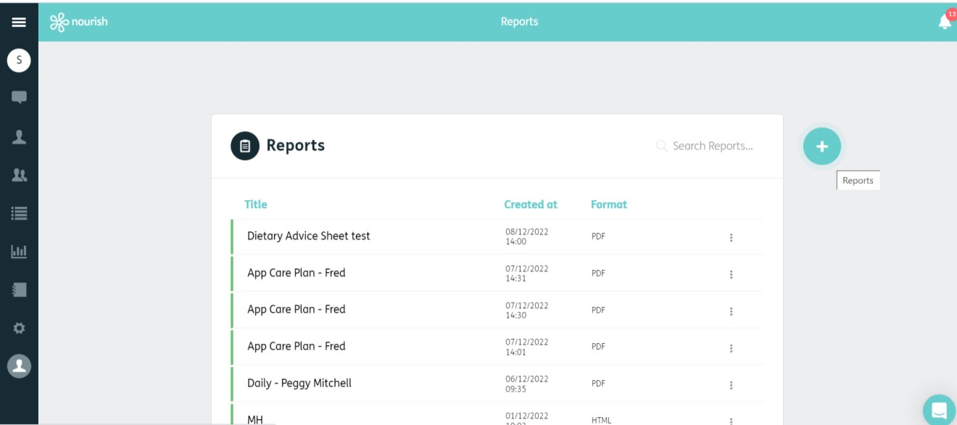
3.

- You can now create a new report, choose ‘Timeline’ from the drop-down box.

- Give your report a title (remember reports stay in the report list)

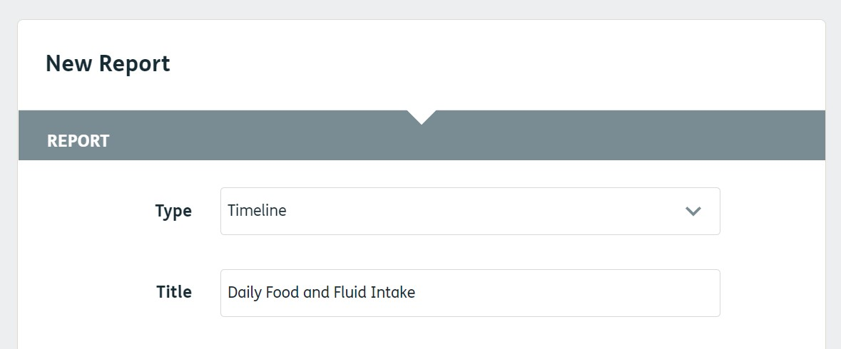

4.
5.

- Choose your date range.

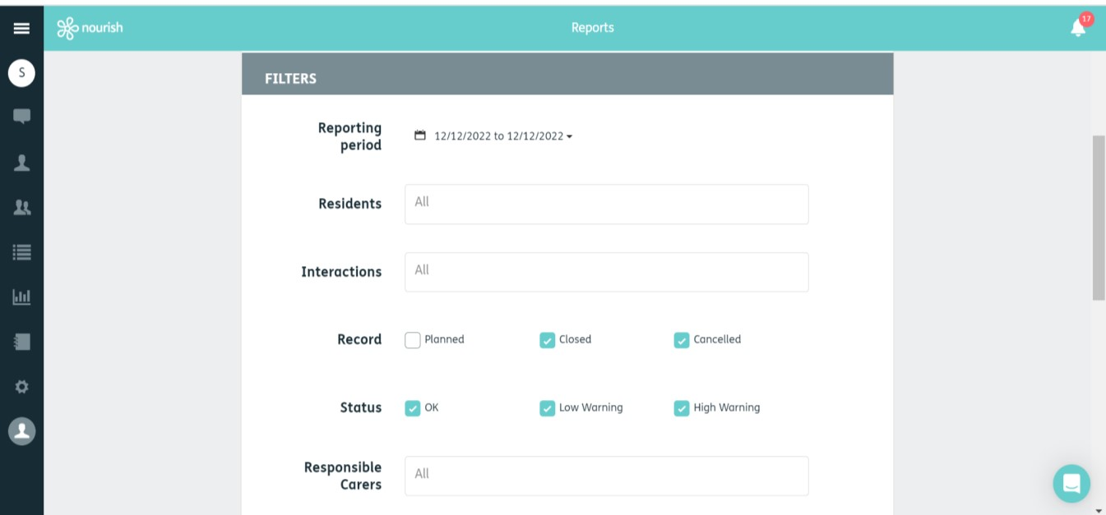

6.

- Choose the resident / residents or leave at ‘All’ (if you start typing a name in the box, it will auto-populate).


7.

- Select the interactions (it will auto-populate if you start typing in the box). For this report you will need to select all interactions relating to Food and Fluid intake – Breakfast / Lunch / Dinner / Snack / Daily Food Intake / Daily Fluid Intake

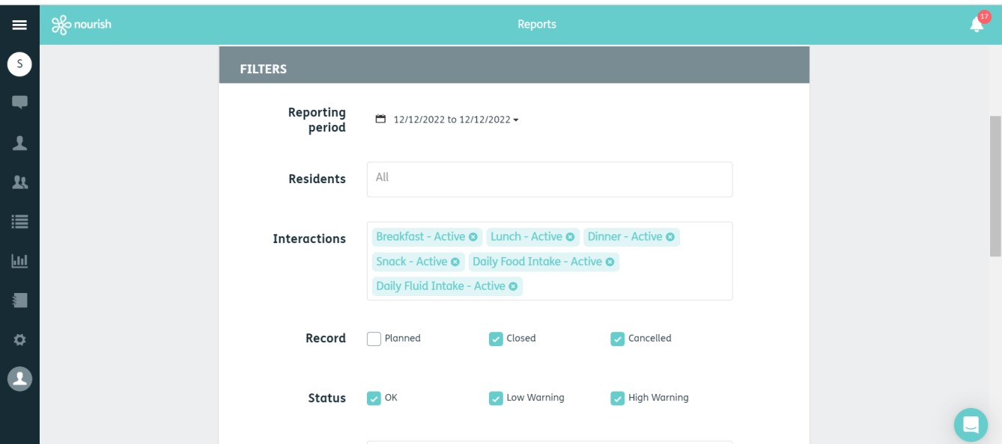
8.

9. Leave the boxes ticked as they are shown below.

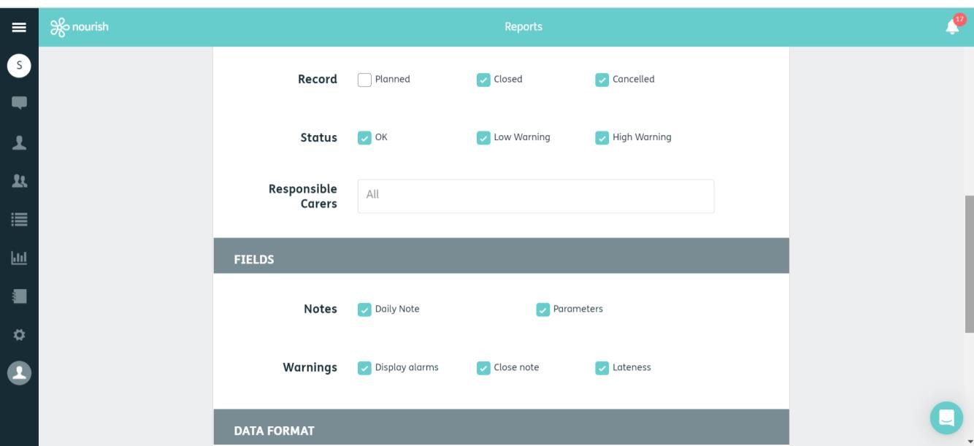
9.
9.

10. You can then select your format (recommended PDF)
- Click Save
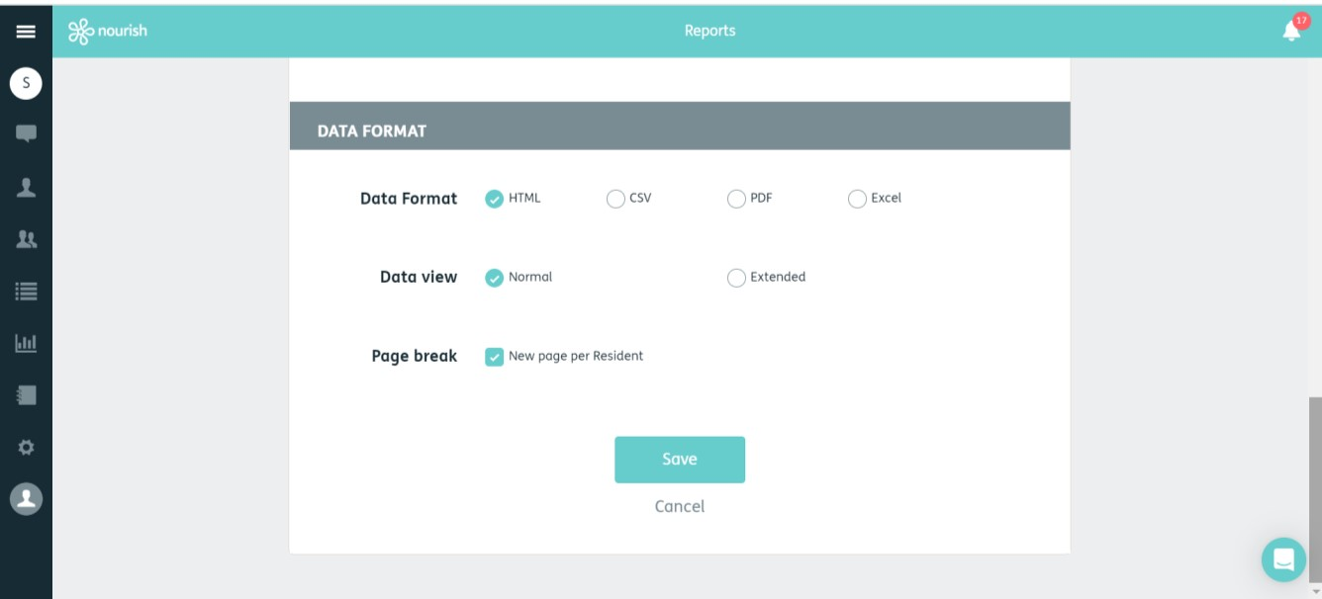
10.

11.

- You can now download your report.
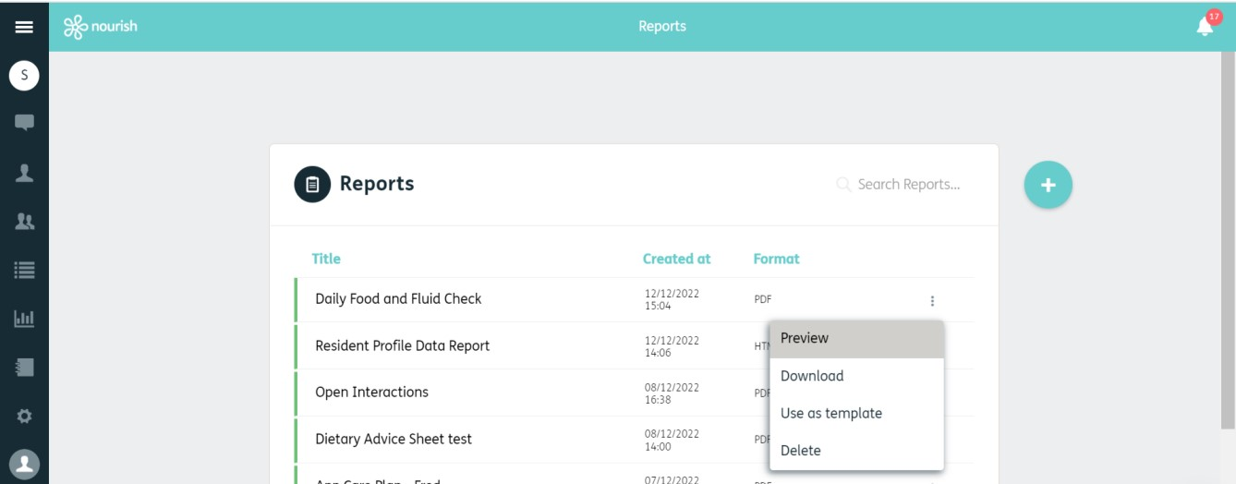
12.

